Statistics and probability Final exam 2 2019-2020

Solution

**Exercise 1:**

P(X=2)= 0.2109=4!/2 ! 2 !

P(X≤1)= P(X=0)+P(X=1)=0.316+0.421=0.737

**Exercise 2:**

1. µ=12.005
2. ϭ=0.026
3. P(X<12)=0.04/0.09=0.44

**Exercise 3:**

1. 15.39%, found by (8 -10.3)/2.25 =-1.02, then 0.5000 -0.3461 =0.1539.
2. 17.31%, found by: *z=* (12-10.3)/2.25= 0.76. Area is 0.2764. *z* = (14- 10.3)/ 2.25= 1.64. Area is 0.4495. The area between 12 and 14 is 0.1731

**Exercise 4:**

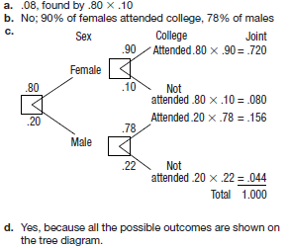

**Exercise 5:**

1. t distribution since the standard deviation of the population is unknown
2. the level of significance 0.05
3. Reject H0 when t > 1.833.
4. t=(12-10) $√10$/3=2.108
5. reject H0. We cannot conclude the population mean is greater than 10.